EXPERIMENTNO.1(Group A)

Aim: Study of Raspberry-Pi/Beagle board/Arduino and other microcontroller (History & Elevation)

Outcome: At end of this experiment, student will be able to study of different microcontrollers like Raspberry-Pi/ Beagle board/ Arduino
Hardware Requirement: Arduino Software Requirement: Arduino IDE Theory:
Internet of Things:-IoT is short for Internet of Things. The Internet of Things refers to the
Ever growing network of physical objects that feature an IP address for internet connectivity, and the communication that occurs between these objects and other Internet-enabled devices and systems. The Internet of Things (IoT) refers to the use of intelligently connected devices and systems to leverage data gathered by embedded sensors and actuators in machines and other physical objects. In other words, the IoT (InternetofThings)canbecalledtoanyofthephysical objects connected with network.

Examples of IoT:-
- Apple Watch and HomeKit.
- SmartRefrigerator.
- SmartRefrigerator.
- Smartcars.
- GoogleGlass.
- Smartthermostats.
  - Raspberry-Pi:- The Raspberry Pi is a series of small single-board computers developed in the United Kingdom by the Raspberry Pi Foundation to promote teaching of basic computer science in schools and in developing countries. It does not include peripherals (such as keyboards and mice).TheRaspberryPiisalowcost,credit-cardsizedcomputerthatplugsinto a computer monitor or TV, and uses a standard keyboardandmouse.Itisacapablelittledevice that enables people of all ages to explore computing, and to learn howtoprograminlanguages like Scratch and Python.
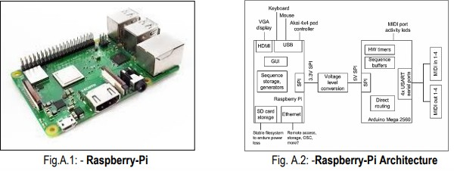

Here are the various components on the Raspberry Piboard:
- ARM CPU/GPU -- This is a Broadcom BCM2835 System on a Chip (SoC) that's made up of an ARM central processing unit (CPU) and a Video core 4 graphics processing unit(GPU).
- GPIO— These are exposed general-purpose input/output connection points that will allow the real hardware hobbyists the opportunity to tinker.
- RCA -- An RCA jack allows connection of analog TVs and othersimilaroutputdevices.∙Audio out -- This is a standard 3.55-millimeter jack for connection of audio output devices such as headphones or speakers. There is no audio in.
- LEDs--Light-emitting diodes ,for your entire indicator light needs.
- USB -- This is a common connection port for peripheral devices of all types (including your mouse and keyboard).
- Power -- This is a 5v Micro USB power connector into which you can plug your compatible power supply.
- SD card slot -- This is a full-sized SD card slot. An SD card with an operating system (OS) installed is required for booting the device.
- Ethernet -- ThisconnectorallowsforwirednetworkaccessandisonlyavailableontheModel B.
  - Beagle board: - The Beagle Board is a low-power open-source single-board computer produced by Texas InstrumentsinassociationwithDigi-KeyandNewarkelement14.TheBeagle Board was also designed with open source software development in mind, and as a way of demonstrating the Texas Instrument'sOMAP3530system-on-a-chip.]
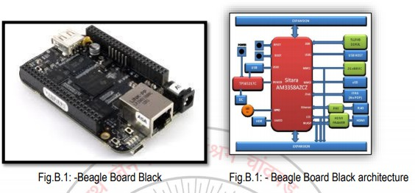

Here are the various components on the Beagle board:
Processor:AM335x1GHzARM®Cortex-A8
- 512MBDDR3RAM
- 4GB8-biteMMCon-boardflashstorage
- 3Dgraphicsaccelerator
- NEONfloating-pointaccelerator
- 2xPRU32-bitmicrocontrollers

Connectivity
- USBclientforpower&communications
- USBhost
- Ethernet
- HDMI
- 2x46pin headers

SoftwareCompatibility
- Debian
- Android
- Ubuntu
- Cloud9IDEonNode.jsw/BoneScriptlibrary
- plus,much more
  - Arduino: - Arduino is an open-source hardware and software company, project and user community that designs and manufactures single-board microcontrollers and microcontroller kits for building digital devices and interactive objects that can sense and controlobjectsinthe physical and digital world. Arduino board designs use a variety of microprocessors and controllers. Theboardsareequippedwithsetsofdigitalandanaloginput/output(I/O)pinsthat may be interfaced to various expansion boards or breadboards (shields)andothercircuits.The boards feature serial communications interfaces, including Universal Serial Bus (USB) on some models, which are also used for loading programs from personal computers.
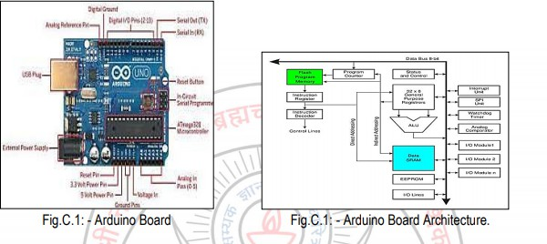

HerearethevariouscomponentsontheArduinoboard:
Microcontrollers
ATmega328P(usedonmostrecentboards)
ATmega168(usedonmostArduinoDiecimilaandearlyDuemilanove) ATmega8 (used on some older board)

DigitalPins
In addition to the specific functions listed below, the digital pins on an Arduino board can be used for general purpose input and output via the pinMode(), digitalRead(), and digitalWrite() commands.

AnalogPins
Inadditiontothespecificfunctionslistedbelow,theanaloginputpinssupport10-bit analog-to-digital conversion (ADC) using the analogRead() function..

Power Pins
- VIN (sometimes labelled "9V"). The input voltage to the Arduino board when it's using an external power source
- Other Pins
- AREF.Referencevoltagefortheanaloginputs.UsedwithanalogReference().
- Reset. (Diecimila-only) BringthislineLOWtoresetthemicrocontroller.Typicallyusedtoadda reset button to shields which block the one on the board. ∙ Analog Reference pin (orange) ∙ Digital Ground (light green)
- DigitalPins2-13(green)
- Digital Pins 0-1/Serial In/Out - TX/RX (dark green)-Thesepinscannotbeusedfordigitali/o (digitalRead and digitalWrite) if you are also using serial communication (e.g. Serial.begin).
- ResetButton-S1(darkblue)
- In-circuitSerialProgrammer(blue-green)

- AnalogInPins0-5(lightblue)
- PowerandGroundPins(power:orange,grounds:lightorange)
- ExternalPowerSupplyIn(9-12VDC)-X1(pink)
- Toggles External Power and USB Power (placejumperontwopinsclosesttodesiredsupply)- SV1 (purple)
- USB(usedforuploadingsketchestotheboardandforserialcommunicationbetweenthe board and the computer; can be used to power the board) (yellow)
------------------------------------------------------------------------------------------------------------------------
Conclusion:-


-------------------------------------------------------------------------------------------------------------------------

Questions:

